Given two binary search trees root1 and root2.

Return a list containing *all the integers* from *both trees* sorted in **ascending** order.

**Example 1:**

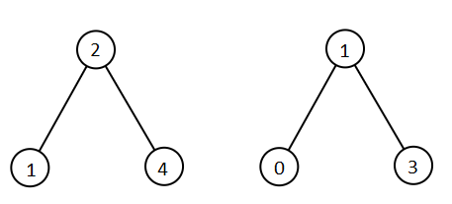

**Input:** root1 = [2,1,4], root2 = [1,0,3]

**Output:** [0,1,1,2,3,4]

**Example 2:**

**Input:** root1 = [0,-10,10], root2 = [5,1,7,0,2]

**Output:** [-10,0,0,1,2,5,7,10]

**Example 3:**

**Input:** root1 = [], root2 = [5,1,7,0,2]

**Output:** [0,1,2,5,7]

**Example 4:**

**Input:** root1 = [0,-10,10], root2 = []

**Output:** [-10,0,10]

**Example 5:**

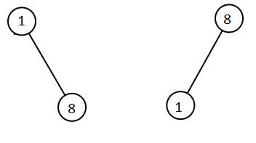

**Input:** root1 = [1,null,8], root2 = [8,1]

**Output:** [1,1,8,8]

**Constraints:**

* Each tree has at most 5000 nodes.
* Each node's value is between [-10^5, 10^5].